**ASSIGNMENT - I**

1. Explain the construction and working of a Light Emitting Diode (LED).
2. Explain in brief the formation of depletion region in a P-N Junction diode under no-bias condition.
3. Explain the avalanche breakdown mechanism in a P-N Junction diode.
4. With a neat circuit diagram and waveforms, explain the working of a half-wave rectifier, and derive the expression for Vdc. Explain what is meant by Peak Inverse Voltage (PIV) for a rectifier circuit. Determine the same for a HWR.
5. The primary to secondary turns ratio of a transformer used in a HWR is 20:1. If the primary is connected to the power mains: 220V, 50Hz, Calculate D.C voltage across the 1KΩ load resistor. Also find the diode current.
6. Determine the value of Vdc and Vac developed across the load assuming all the diodes to be ideal in the following circuit. Also find the frequency of the AC voltage in the load. Transformer turns ratio is 10:1. AC Supply voltage is 230V, 50Hz.

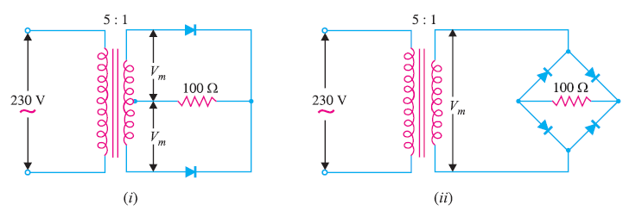

1. The turn’s ratio of a transformer used in a Bridge Rectifier is 12:1. The primary is connected to the power mains: 220V, 50Hz. Assuming the diode voltage drops to be zero, (a) Calculate the D.C voltage across the load resistor. (b) What is the PIV of the diode? If the same dc voltage is obtained by using Center tapped FWR, what is the PIV?